ExplicitWait :

Scenario -1 :

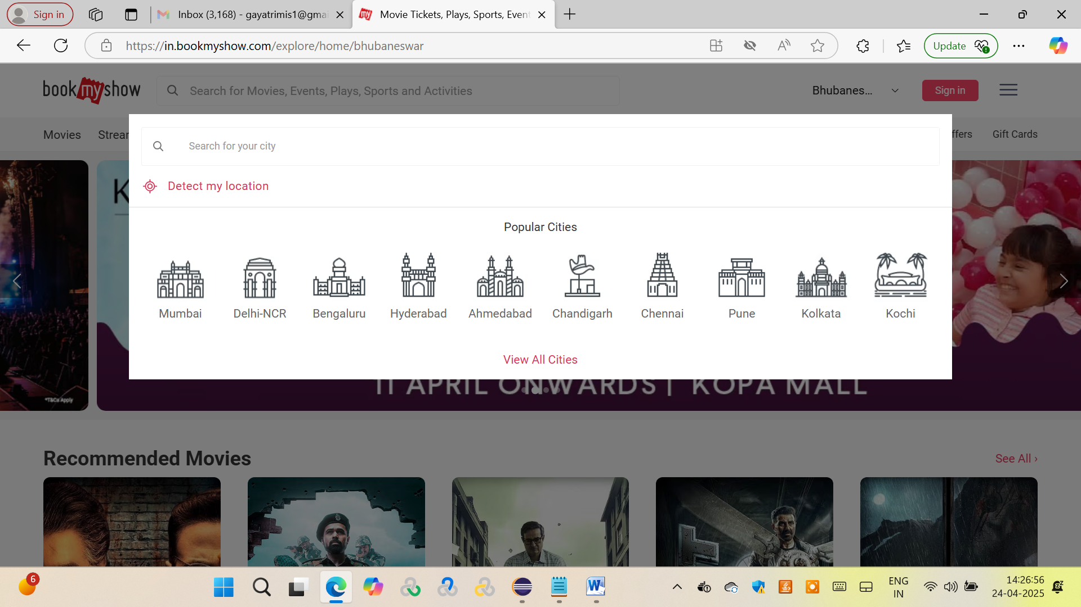

Step-1:

Invoke bookmyshow application.

Step-2:

Enter your city in search city inputbox. [Use explicit wait here]

Step-3:

Click enter .

**Scenario – 2:**

Step-1:

Invoke book my show app

Step-2:

Enter Mumbai as a location

Step-3:

Click on search

Step-4:

Calculate the number of Movies released in Mumbai Location

Step-5:

Get all the movies list from Mumbai location.

Assertions :

Step-4 Count number of movies

Step-5 Movies list for Mumbai location

**Scenario – 3:**

Step-1:

Launch the book my show app.

Step-2:

Enter the location as Mumbai.

Step-3:

Click on Movies tab.

Step-4:

Filter the English Movies released in Mumbai location and display the movies.

Step-5:

Count total number of movies released in Mumbai location.

Assertions :

Step-4 Movie List

Step-5 Movie Counts

**Scenario-4 :**

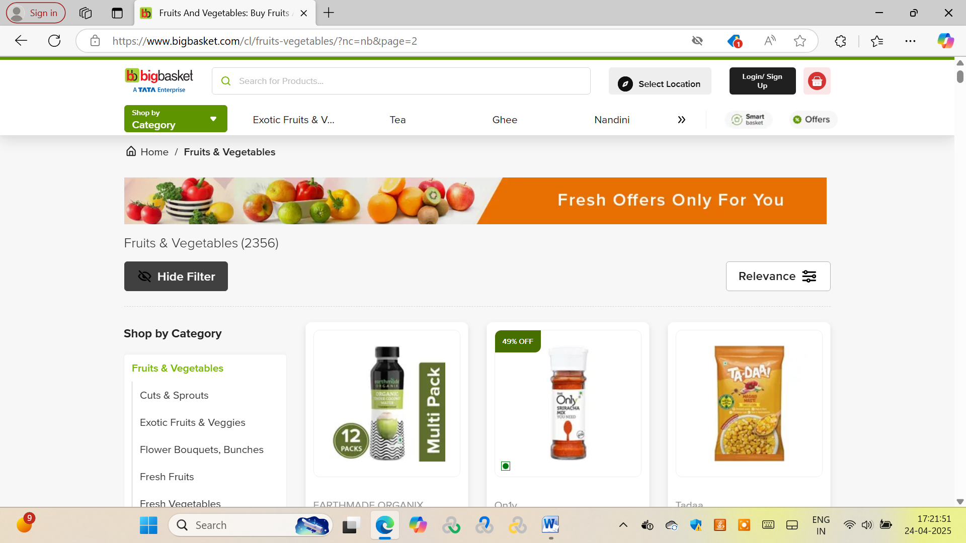

**Show Filter / Hide Filter assertion**

Step-1:

Launch the big-basket application.

Step-2:

Identify the Show Filter button below the sort by category. Assert the text.

Step-3:

Click on Show Filter button . Check if the name is getting changed to Hide Filter.

Assert the same.